What is a School-Parent Compact?  A School-Parent Compact is an agreement that families, students, and teachers develop together. It explains how families and teachers will work together to make sure all students reach or exceed grade-level standards.  - Link goals to the School Improvement Plan  - Focus on student learning skills  - Describe how teachers will help students develop skills using high-quality instruction  - Share strategies families can use at home.  - Explain how teachers and families will communicate about student progress.  - Describe opportunities for parents to volunteer at school. | Activities to Build Partnerships  Fairmount staff truly believe in our motto, “Together we learn, united we soar!” We would like to invite families to participate in Fairmount partnership events throughout the year, which include the following:  School Day events: Read Across America, Jump Rope for Heart, Field Day, and 5th Grade Graduation Events – community donations, Leader in Me Events, PTA events, HYPE Days  Parent engagement nights: Reading Party Nights, Haunted Hallways, Spring Fling / Book Fair, Preschool & Kindergarten Registration, Grade Level Musical Productions, Open House, & PTA Meetings  After school partnerships: LEAPS and Coalition for Kids (C4K) Hearts for the House, Run Club, Elementary Sports-Basketball, Cheer, and Soccer, grade level partnership opportunities vary, and VEX Robotics  Summer partnerships: AR Summer Program, Summer Meal Program, Book Bus, Summer STREAM Camp  Community partnerships: Santa Pal, Lion’s Club – glasses, Kiwanis Club – shoes, Eastman MathElites / SciencElites, Box Tops, Food City School Bucks – link your Value Card, Reading Buddies, Dominos donations, First Presbyterian Church Supports | Fairmount Elementary School  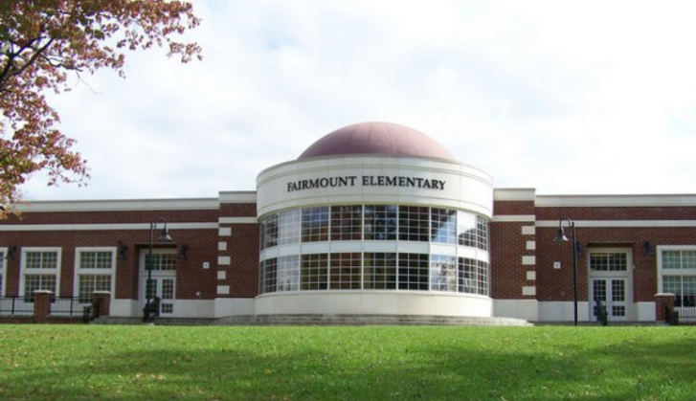  School-Parent  Compact  2023-2024  Principal: Trey Arrington  Program Assistant: Tracy Easterling,  Jeremy Culbertson  School Secretary: Stephanie Odum  Fairmount Elementary School Website:  http://fairmount.btcs.org/  (423) 652-9311
Jointly Developed  The families, students, and staff of Fairmount Elementary School developed this School-Parent Compact. Teachers suggested home learning strategies, families added ideas to make them more specific, and students told us what would help them learn. Meetings and events are held each year to review the compact and make changes based on student needs.  Families are welcome to contribute comments and suggestions at any time. If you would like to volunteer at our school, please contact Joseph Lara at (423) 652-9311. | Communication About Student Learning  Fairmount Elementary School is committed to frequent two-way communication with families about students’ learning. Some of the ways you can expect us to reach you are:  - Daily folders or binders  - Weekly Wednesday Folders  - Notes, phone calls, Fairmount Facebook, or emails  - Updates on the school website, Canvas, and current grades in PowerSchool  - Report Cards, Interims, and Progress Monitoring Reports  - Fall and spring Parent-teacher conferences  - Administrative Newsletters  If you have questions about your child’s progress, please contact your child’s teacher by phone (423) 652-9311 or email. Email addresses are listed on the school website at http://fairmount.btcs.org/.

Our Goals for Student Achievement
Increase the percentage of students who are on track or mastered on TCAP for grades 3-5 ELA in 2024.  Increase the percentage of students who are on track or mastered on TCAP for grades 3-5 math in 2024.  Fairmount Elementary School Goals  Fairmount Elementary School administrators and teachers have studied our student achievement data to determine the most important areas for improvement for our school. Fairmount staff, students, and families will work together to establish and monitor individual goals for students.  Reading - Student Learning/Quality  Fairmount Elementary will increase the percent of students scoring above the 25th percentile in reading by three percent during the 2023-2024 school year.  Strategic Actions  - Utilize Walk to Learn Period (SOAR)  - Curriculum Implementation  Math - Student Learning/Quality  Fairmount Elementary will increase the percent of students scoring above the 25th percentile in math by three percent during the 2023-2024 school year.  Strategic Actions  - Utilize Walk to Learn Period (SOAR)  - Curriculum Implementation  Whole Child Supports- Fairmount will decrease the number of office referrals during the 2023-2024 school year by five percent.  Strategic Actions  - Implement multi-tiered system of supports for behavior  - Provide intensive support for students in Tier II and Tier III  - Implement Leader in Me for all students  - Participate in the Trauma Informed Cohort  Attendance: Fairmount will meet or exceed the AMO for chronic absenteeism during the 2023-2024 school year.  Join our Parent Teacher Association  PTA  Fairmount Elementary has an active parent teacher association. We encourage all families to join our PTA and help support the students at Fairmount. If you are interested in joining or volunteering time, please reach out to Kayla Reasbeck, PTA President, or the front office for more information. | In the Classroom  Each grade level team will work with students and families to support students’ success in reading and math. Some of our key connections with our families will be:  The Fairmount school website provides links to build educational skills on the special area and class pages, such as Reflex Math. Students can access their Fairmount library books to work on their Accelerated Reader goals.  Preschool:  - Preschool newsletters will feature skills to practice.  - Provide pre-decodable books for picture reading practice.  Kindergarten - 2nd grade classes:  - Our newsletters will feature skills to reinforce and practice.  - Provide library or pre-decodable books for reading practice.  3rd – 5th grade classes:  - Our newsletters will feature skills to reinforce and practice.  - Students can use their laptops to access the following at home: Moby Max, Quizlet, Brainpop, Reflex Math, Prodigy, NewsELA, Powerschool, OneNote, and Canvas.  - Parents can create their own Powerschool and Canvas access to check students’ progress toward their goals. |  | At Home  Fairmount families joined staff to develop ideas about how families can support students’ success in reading and math. Some of our key home activities will be:  - Set goals with your child and check their progress often on PowerSchool and A.R. Home Connect.  - Plan to attend parent – teacher conferences to get more information about their performance towards goals.  - Establishing a daily routine, teaching organization skills, attending school daily, and arriving on time with their materials will foster your child’s success.  - Maintain open communication sources for teachers to make contact such as current phone numbers, emails, etc.  - Check your child’s backpack to use the nightly folder or binder and Weekly Wednesday folder to discuss your child’s learning goals and use the teacher’s materials to support your child’s learning at home.  - Look for class newsletters and check out the school website http://fairmount.btcs.org/  - Read with your child or have them read to you every day. Talk about how the story connects with things that he or she has experienced.  - Attend reading party nights to practice new ways to support your child as a reader.  - Use vocabulary, spelling, and sight words in conversations with your child about their day  - Use the math goals in related games or strategies the teacher sends home to improve your child’s math fluency.
Students

Fairmount students joined staff and families to develop ideas about how they can succeed in school and reach for the stars in math and reading. Students thought of the following ideas to make connections between learning at home and school:

- Follow school expectations by: being respectful, being safe, being responsible, and being kind.
- Monitor your progress towards the goals you want to achieve on PowerSchool and Aimsweb.
- Talk with your family about what you are learning in class and about new vocabulary words.
- Bring home daily folders or binders, Weekly Wednesday folders, homework, and teacher made materials to study for your academic success.
- Bring home your class newsletters and invitations for Family Fun Nights.
- Use suggested websites to practice fluency.

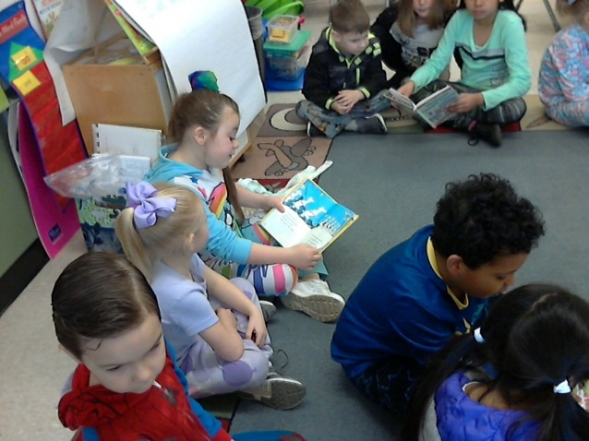

When teachers, students, and families work together, we CAN achieve our goals!

